**The Maze Solving Robot’s Wheel and Caster Positioning**

Our maze-solving robot uses two wheels and two ball casters symmetrical to each other located close to the robot’s plate’s ends. This equalizes the front and rear weights that the wheels need to carry. With this positioning, the robot does not need to move in a curve during turning as well, since it can rotate itself without changing its location. Two ball casters are used to let the robot’s plate be parallel to the surface.

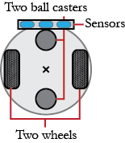Precision and motion smoothness is demanded in this robot, since the robot must not move away from the line so that the sensors can constantly read the input correctly in order to execute the right action every time. For that reason, the wheels need to have the least disturbance from slipping and frictions. A rubber wheel is an ideal choice in this case. To choose the right wheel, the size of the robot needs to be taken into consideration. Before that, most importantly the line thickness and lengths need to be measured.

**Figure 1:**  
The robot’s sensors, wheels

and ball casters’ positioning

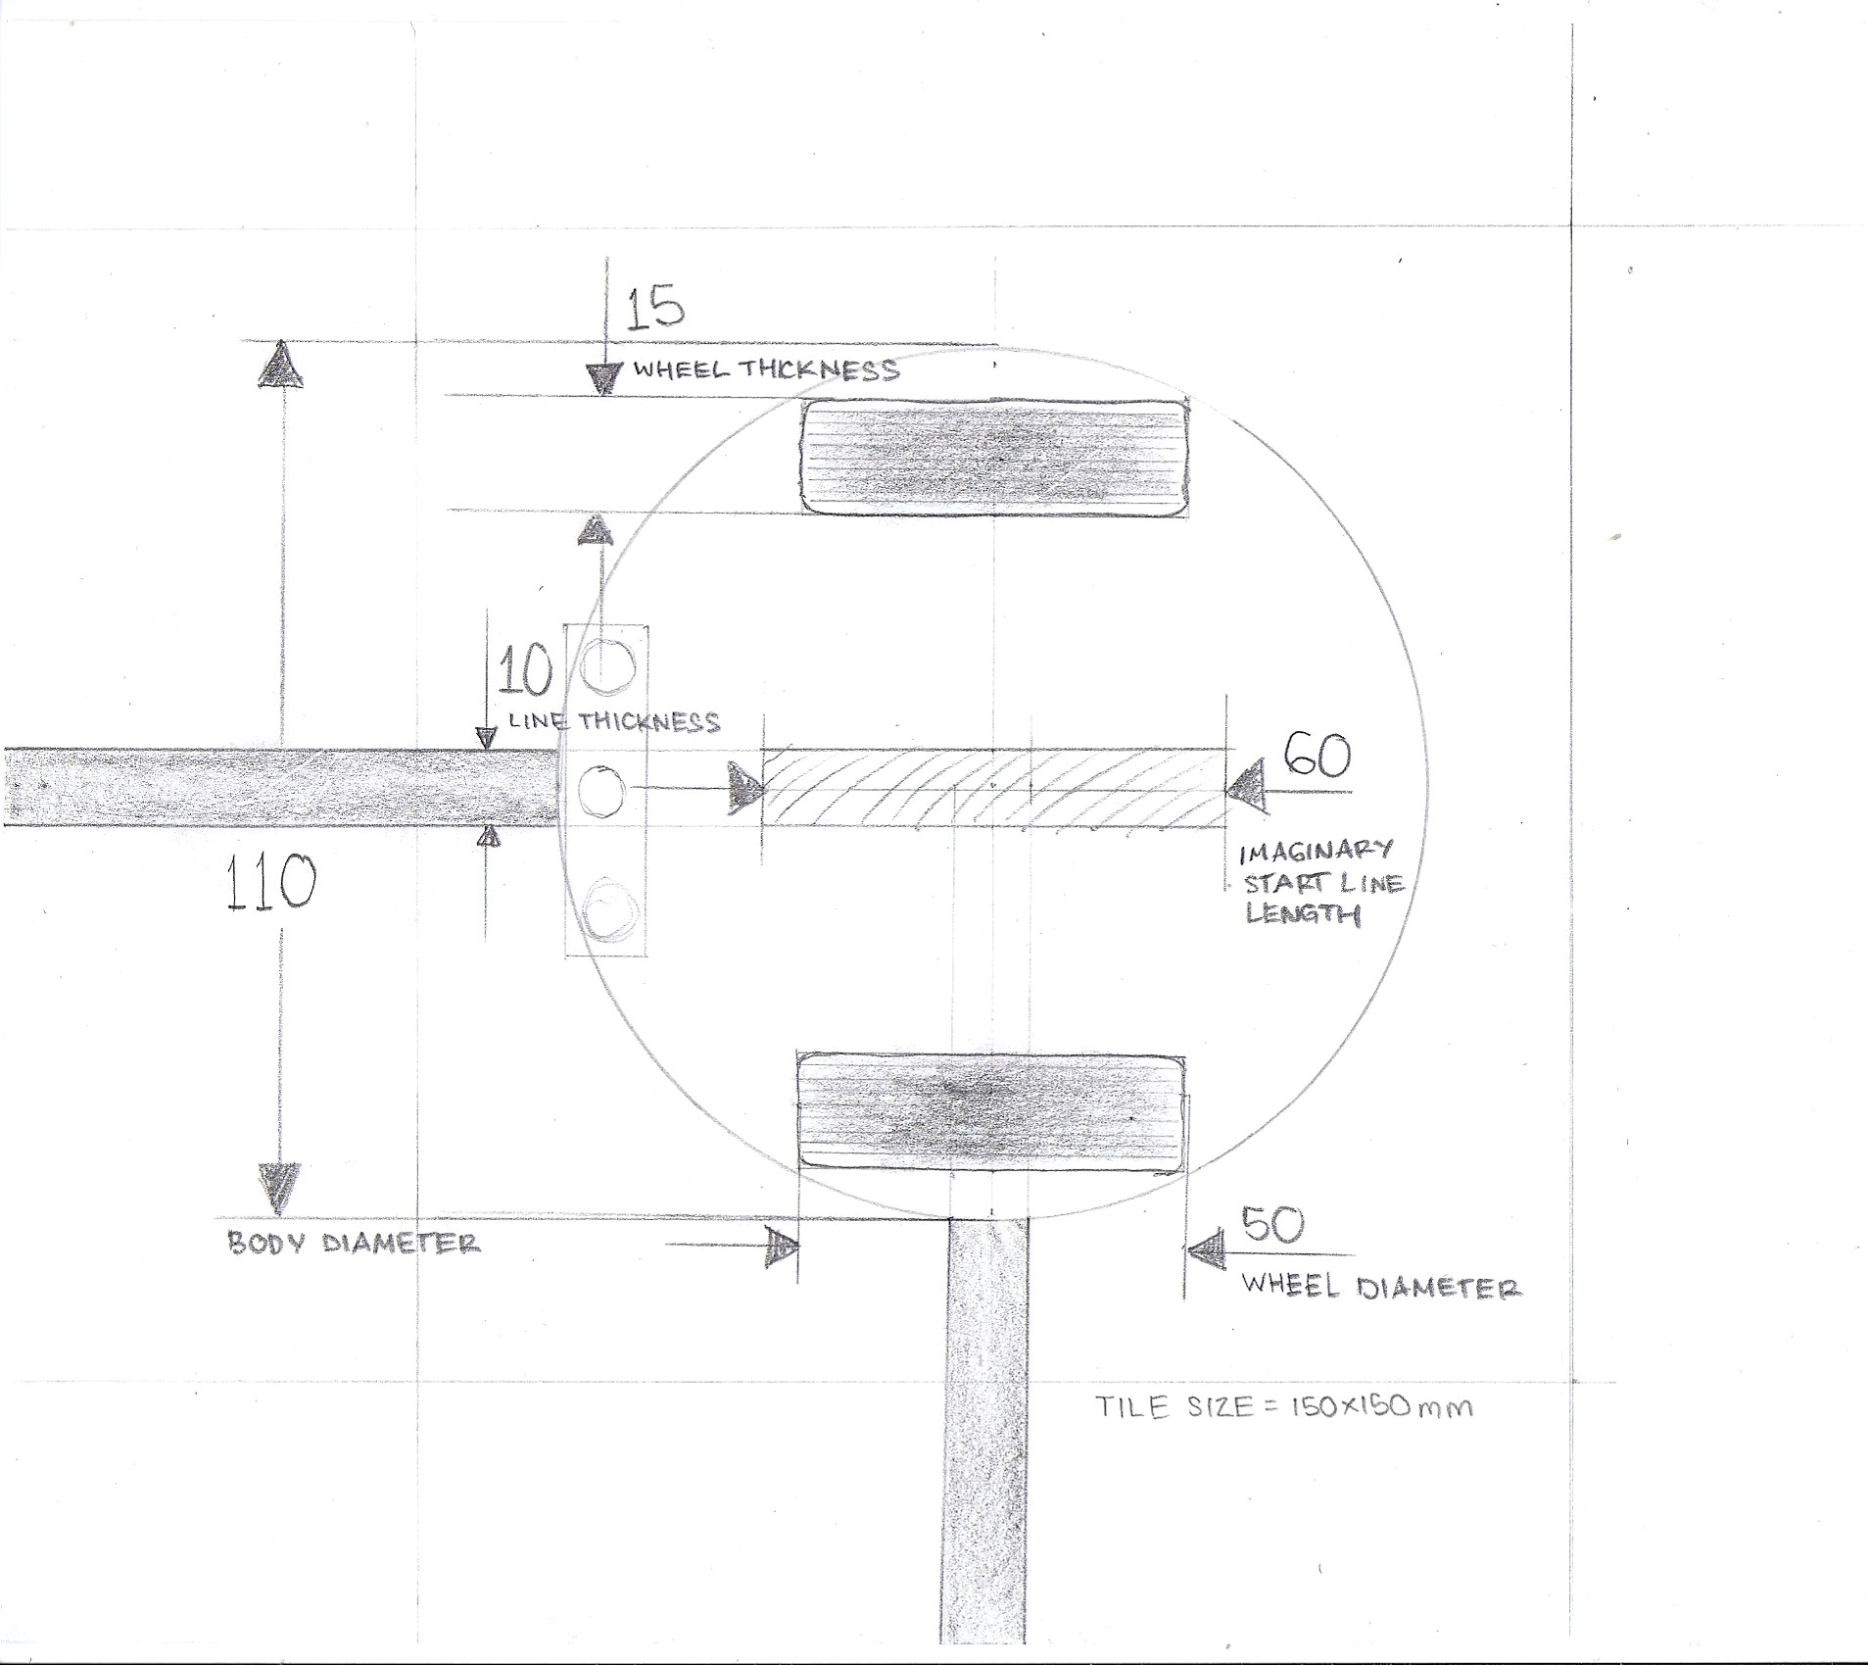

35

10

10

10

**Figure 2**: The sketch of the robot in a turning point on a tile. (The lengths are in millimeters)

For wheel choice, a line with 10mm thickness is assumed. The starting line is 60mm long. Thus, our first assumption for the robot’s body’s diameter is 110mm. From these, the wheels are chosen to have 35mm diameter and approximately 10mm thickness.

For ball casters, the model TAMIYA 70144 has an ideal size for this robot. The wheel diameter’s choice also has the ball caster’s height taken into consideration.

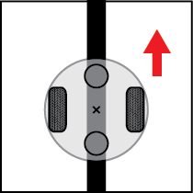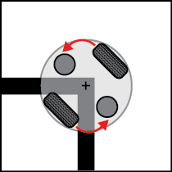

Figure 3 : The robot’s motion.

Figure 3 shows the basic portrait of how the robot would move. Powered by DC motors, the 2 wheels rotate in the same direction during straight movement. It is believed that the robot would not make a significant misdirection with the rubber tire chosen and proceeds forward smoothly. During turns, the robot would stop when its center is right on the pivot. From there, the robot is programmed to turn towards where the line continues.

Idea for sensor:

Probably we can make the sensor can be put far enough so that the starting line cannot be sensed to distinguish a T intersection and the starting line, since the sensor would still naturally be able to sense the black line no matter how far it is located from the center.

So the programming can be like: (L=Left, C=Center, R=Right)

When the sensors sense: L=Black C=Black R=Black, it has to determine whether it is a T intersection or a starting line. But before that, make the robot move a bit forward to make the center right on the pivot. From there, make the robot rotate 90° either left or right. If the L, C, R=White, then it's a starting line and make the robot continue rotating. If the sensors sense black, then it’s a T intersection, then make it stop rotating.